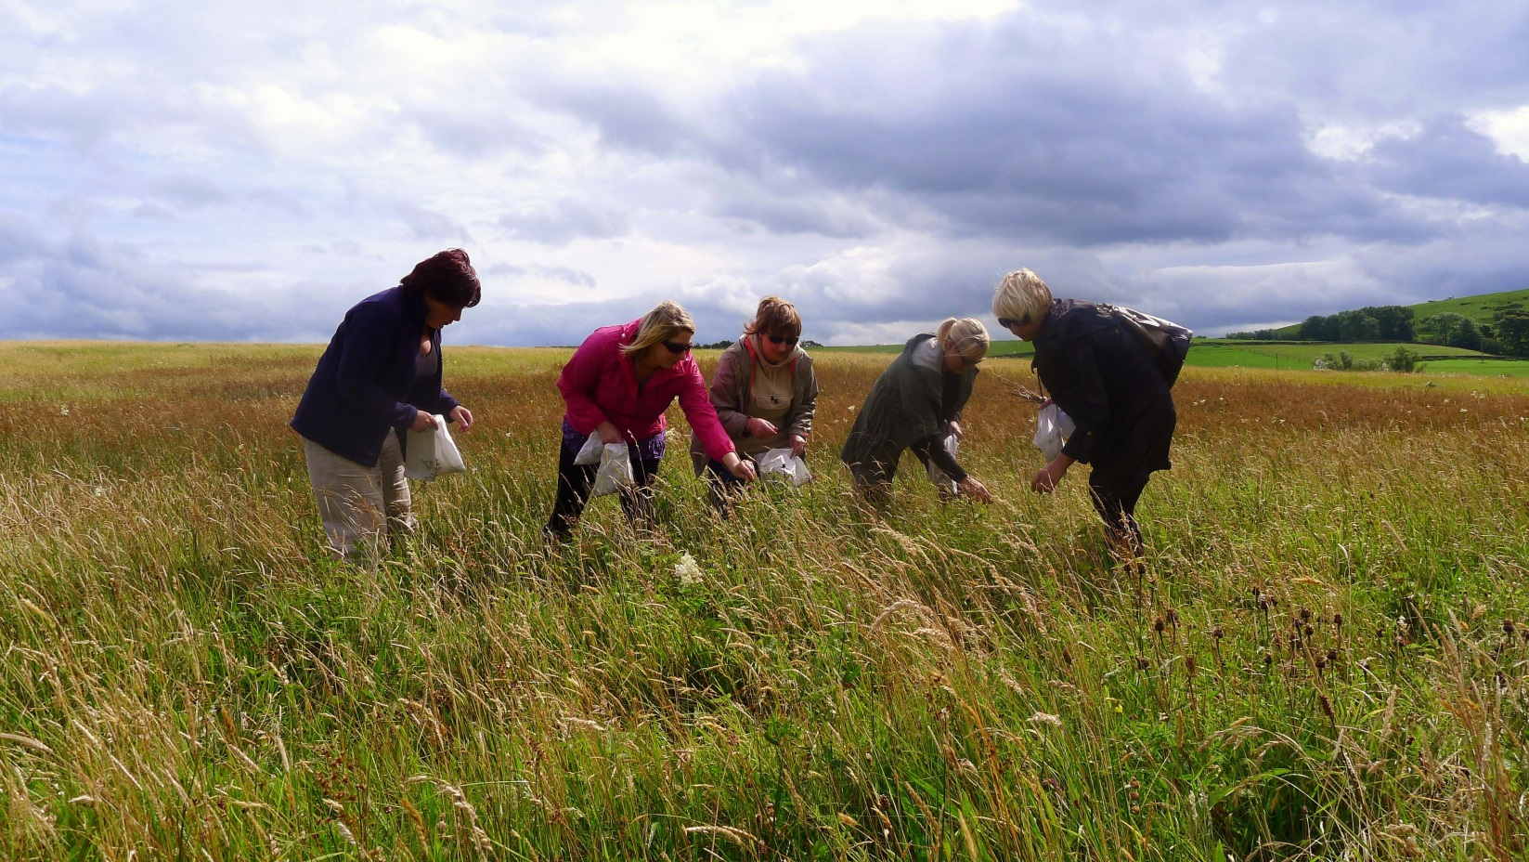
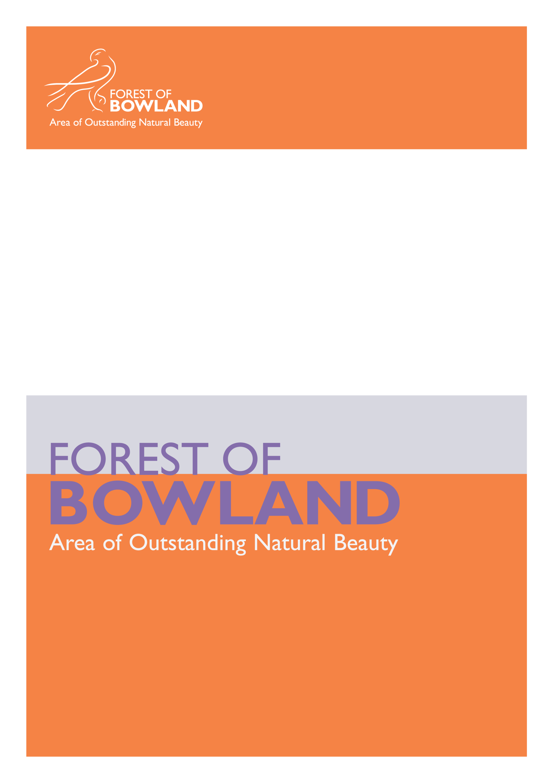
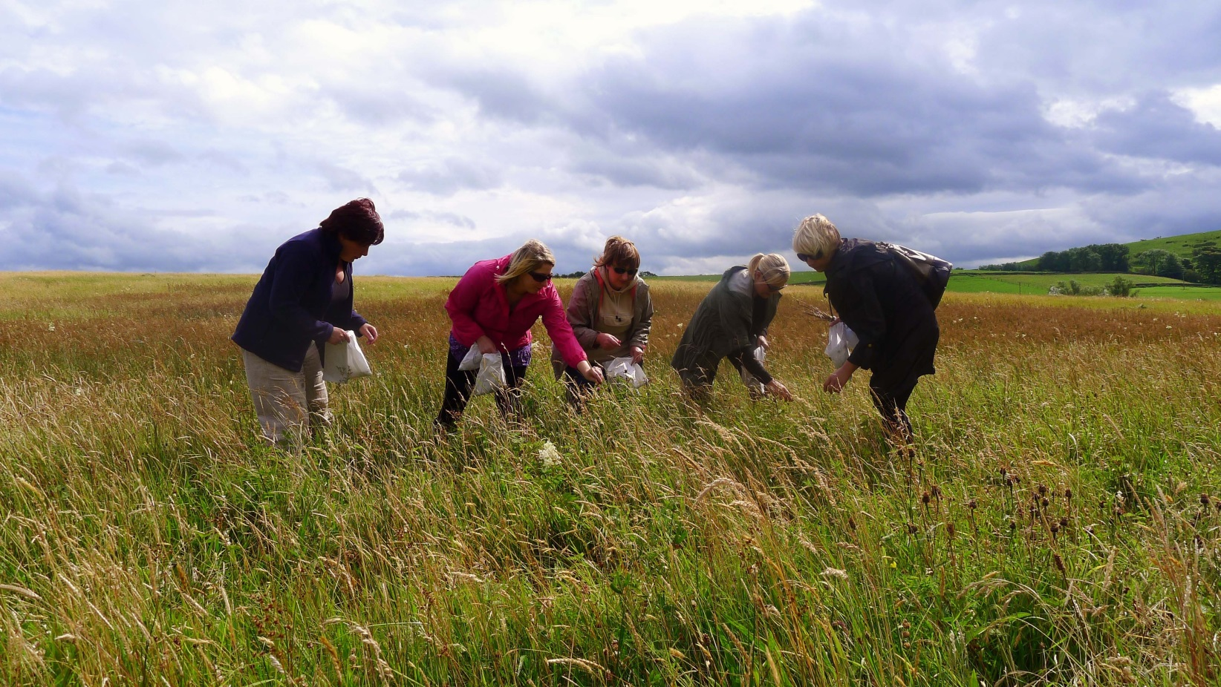
AONB Report to JAC: October 2013

An outstanding landscape of natural and cultural heritage

Moorland Restoration
The AONB's involvement in peat restoration and access work on the Bowland Fells SSSI is continuing. Tarja Wilson has been assisting moor owners Len and Mary-Beth Morris with their HLS plans to restore the bare peat on Wolf Fell. Using the same techniques as used previously in the Environment Agency funded work on Bleasdale, the contractors are already on site re-profiling the eroding peat hags, in preparation for the area to be limed and re-seeded in the spring time. Whilst the contractors are on site, they will also be tackling the eroding access route desire line along the ridge of Wolf Fell between Parlick and Totridge, creating a clay path away from the hazardous areas of eroding peat.

During May and June this year over 40 'employee volunteer' days were provided by Environment Agency staff who joined Environmental Project Officers and local volunteers on Bleasdale fells. Over the past 2 years the eroding exposed peat has been re-profiled, stabilised and reseeded. The volunteers helped to revegetate the peat by planting a total of 3000 cottongrass, crowberry, bilberry, heather, cowberry plug plants and relocating sphagnum. The volunteers also set up monitoring transects which are been used for data collection over the next few years to help measure how successful the restoration work has been.
For further information contact tarja.wilson@lancashire.gov.uk or sarah.robinson@lancashire.gov.uk

Bowland Hay Time Project
One of the highlights from May this year was a call from Plantlife asking for assistance in nominating the Coronation Meadow for Lancashire. In conjunction with the Lancashire Wildlife Trust, who were coordinating the nominations, Bell Sykes Meadows, Slaidburn were accepted. The Coronation Meadows project, initiated by HRH Prince Charles, has listed 60 meadow sites to become donors for further restoration work. The sites need to be species rich, open to the public and the owners need to be willing to take part in restoration schemes. Bell Sykes fits the bill perfectly, with 4 SSSI meadows and 1 BHS meadow covering a total of 12 hectares, a network of footpaths across the farms, a downloadable meadow walk which we have developed as part of the Hay Time Project, as well as 6 hectares of meadows where we spread green hay last August – this is now stuffed with yellow rattle and eyebright. Peter Blackwell from Bell Sykes Farm went to Highgrove for the launch of the Coronation Meadows, his impressions of the day were that the meadows at Highgrove were 'not a patch' on his, and that the weather was far too hot, compared to Slaidburn.
This summer we had a target of restoring 20 hectares of meadows, as well as a further 3 to make up for being a bit short last summer. So far this summer we have worked on a total of 25.3 hectares on 8 sites, ranging in size from 7.6 ha down to 1.3 ha. These schemes have been green hay schemes, and in the main have been funded by HLS agreements. However, a welcome development this year has been the interest in the project from people outside of the scheme willing to pay for restoration themselves – for example at the Inn at Whitewell, where the owner was keen to restore a meadow specifically to help feed his new bees.
We have a further 10 ha of restoration and enhancement work to complete in September and October, smaller sites where vacuum harvested seed will be broadcast by hand onto pre-prepared sites and where plug plants will be planted, with the help of volunteers. If all that goes to plan, we will have worked on a total of 35.3 ha this summer, well in excess of our target of 23 ha.
As well as the restoration work on site, keeping the donors and recipients informed and up to date with progress, we've been busy collecting seed using the vacuum hoover, and now have well in excess of 15kg seed ready for the first of our enhancement schemes which happened on 12th September. This is a really exciting scheme, where together with the year 4 class from Higham Primary School, the owners at Height Top Farm and project officer Sarah Robinson broadcast seed in a 0.48 hay meadow. More schemes will follow, the last being the plug planting days which are due for the middle of October. These plug plants have been growing in pots outside the office at Dunsop Bridge, having been planted in pots with the help of the Bowland Outreach pilot project from seed collected by volunteers last summer.
The seed propagation leaflet has now been completed, we are very pleased with the result, and it will be used with the seed collecting work here in Bowland.
The project has had some really good press coverage this summer, a two page spread in Lancashire Life, two features in the Craven Herald and a page article in Rural Life to name a few. The Coronation Meadows project has really helped to raise the profile of meadows and the need for restoration.
Over the coming months we will be collating all the information we have within the project sites into a GIS layer, as well as putting together funding bids to enable the work to continue into next summer and beyond, there is still a lot to do!
For further information contact sarah.robinson@lancashire.gov.uk

Undergrounding for Visual Amenity Programme

As part of the £5.4M OFGEM Undergrounding for Visual Amenity (UVA) programme running from 2010-2015, Electricity North West has been working with the Forest of Bowland AONB to identify visually intrusive sections of overhead lines for undergrounding.

Further to the schemes in Littledale and Roeburndale reported at the last JAC meeting, the fourth and final scheme from Winder to Deep Clough commenced in September 2013 and is scheduled for completion by the end of the year.

In addition two further schemes are still in pre-construction stages:
- Beacon Fell Country Park – wayleaves and permissions have been granted and awaiting pre-construction release from ENWL. Construction is scheduled for completion in early 2014.
- Laund Wood to Middle Lees, near Whitewell – still with ENWL Wayleaves.

For further information contact elliott.lorimer@lancashire.gov.uk

Resilient and sustainable rural communities

Champion Bowland
As well as a new name, Champion Bowland, now also has a new logo and website, have a look at www.championbowland.org.uk
Recent supported projects include a grant to help to set up a new Flower Festival in St. Peters' Church, Scorton as part of the village's "Bikes and Barrows" weekend May 4/6th 2013. This event featured local wildflowers and information about the Forest of Bowland AONB. The Festival was a great success, attracting many visitors and it is hoped will be repeated in future years.
Champion Bowland contributed match funding to a Forest of Bowland Sustainable Development Fund grant to produce promotional and marketing materials for The Bowland Electric Bicycle Network. The network offers visitors a brand new way of discovering the beauty of the Forest of Bowland countryside. Hire electric bikes from the hire-stations with the option to recharge the battery at one of the charge points.
For further information contact mike.pugh@lancashire.gov.uk

Sustainable Tourism Annual Forum
This Sustainable Tourism Forum was held at the Stirk House Hotel, Gisburn on 17th September and was attended by 40 tourism partners, including businesses, officers and councillors. The forum included a packed agenda covering discussions around training, the AONB anniversary, the management plan review, European Charter status and business monitoring. The event highlighted numerous opportunities in which partners & businesses could be involved in future AONB projects, and this was welcomed by the group. Paul Caddy, owner of the Stirk House kindly welcomed everyone to their business and delegates were treated to some fantastic food, tour and an insight into the hotel's green practices.

For further information contact hetty.byrne@lancashire.gov.uk

Gold Star Green Businesses
The 2013 Green Tourism GoldStar Awards had 2,400 contenders nationally, which were whittled down to a shortlist of 63 businesses nominated for 15 awards.
The awards event will be held on 8th November in Bristol, as part of Green Tourism week where the winners will be announced. We are delighted that 4 of the 63 shortlisted businesses are operating in the Forest of Bowland AONB; very well done to them and we wish them well for the awards event. They include Malkin Tower, Blacko (self catering), Caldertop Cottage, Calder Vale (self catering), Waddow Lodge Gardens, Waddington (visitor attraction) and our AONB office at Dunsop Bridge (corporate office).
Also new for 2013 is a Green Destination Award, for the destination which can demonstrate the most progress in raising awareness and delivering change in green tourism. As this is the first year for this award GTBS decided to invite a select number of destinations to be on the shortlist that have been working with Green Tourism over the past 5 years, and we were delighted that the Forest of Bowland AONB is one of those selected destinations. We also find out the winner of this at the conference in Bristol on 8th November.

For further information contact hetty.byrne@lancashire.gov.uk

Sustainable Development Fund
This year the SDF grant scheme has £26,000 available for projects, and to date the panel has awarded £17,716 to six projects. These are:
- the development of the Bowland Electric Bicycle Network
- a young people's art project called 'Farming Then and Now'
- renewable energy at Bleasdale parish hall, and energy efficiency work at Dunsop Bridge village hall
- a community outreach project
- a community energy efficiency programme
This means that there is around £7500 remaining to be committed, and the next closing date for applications is the end of October.
This year the grants are being distributed to projects via Champion Bowland. We have set up this arrangement so that the panel can offer grants for 12 month projects no matter what the start date, and also any unallocated grant can be rolled forward into the next financial year. This will allow us to get around the awkward situation we can face at the end of March when we have to quickly find worthy projects which can spend their grant immediately. A Memorandum of Understanding has been drawn up between the AONB Unit and the Trustees of Champion Bowland: the AONB Unit will continue to manage the fund, and the panel makes decisions on awards; Champion Bowland acts as the banker and is paid a 3% fee (ie £780) to administer the finances.
The grants panel has also been pleased to welcome Chris Dobson (head chef and green team leader at Stirk House Hotel in Gisburn) to join the panel as a local business representative. He joins Colin Price (chair), Kay Hopkinson (community rep), Pete Wilson (biodiversity rep), and John Miller (heritage rep) on the panel.
For further information contact cathy.hopley@lancshire.gov.uk

Bowland Community Outreach Pilot
The AONB has been working with the Yorkshire Dales Millennium Trust (YDMT) and colleagues within Lancashire County Council to facilitate the running of a pilot community outreach project, similar to the People and the Dales initiative organised by YDMT.
The project aims to work with people who perhaps do not regularly visit the AONB, for example, Black and Minority Ethnic (BME communities), refuges and asylum seekers, urban disadvantaged residents, young people and people with disabilities. Principally, the aim of the project is to help support the health and wellbeing of people on the periphery of the AONB who are facing disadvantage, by inviting them into the Forest of Bowland to discover and enjoy the landscape and find out more about the protected area, the people who live and work here and the work of the AONB Unit and our partners.
Following a successful application to the AONB's Sustainable Development Fund, the pilot project itself will involve four groups and will run during September and October. In advance of this, as part of YDMT's People and the Dales dissemination work, we hosted two groups from Blackburn, principally homeless people and refugees/asylum seekers. In July, a group of people from the YMCA visited Gisburn Forest where we helped Sarah Robinson with some Hay Time seed sowing and then went on to find out about Stocks Reservoir and the community archaeology project from Dave Oyston at United Utilities, followed by a visit to the bird hides and a walk through the forest.
Two days later the ARC group came to New Laund Farm above Whitewell where we had a tour of the farm and a sheep shearing demonstration courtesy of farmer, John Alpe, and his son followed by a felt making session with Tracy Ankers from Slaidburn.
For further information contact sandra.silk@lancashire.gov.uk

St. James Church Community Archaeology Project
A booklet recording the community archaeology project carried out at the site of the original St. James' Church in Gisburn Forest has now been produced. The publication follows the work of the volunteers and the professional archaeology team in their quest to uncover the foundations of the church which was demolished following the construction of Stocks Reservoir.
Copies of booklet: "Stocks. The Rediscovery of a Lost Hamlet," are available from Slaidburn Village Archive, with proceeds from sales being shared between the Archive and Champion Bowland.
For further information contact sandra.silk@lancashire.gov.uk

Bowland Land Managers Forum
Since April 2013, the Forum has met twice (in June and September) to discuss a range of farming and land management issues.

In June, Rural Futures/Rural Solutions reported back to the Forum on their work to provide an analysis of the economic profile of the AONB. It is anticipated that this evidence base will help in the review of the AONB Management Plan and inform the development of future rural development funding programmes affecting the AONB.

In September, the Forum hosted Phil Warren from the Game and Wildlife Conservation Trust to report on the findings from a feasibility study on restoring Black grouse to the Bowland Fells. This was an interesting and thought-provoking presentation. The conclusions were that the habitat is all in place in numerous sites in Bowland, but the nearest lek sites are still too distant to support a sustainable population. United Utilities and the Forum plan to work with Yorkshire partners, including the Yorkshire Dale National Park to support efforts to expand the range of the Black grouse population southwards closer to Bowland.

The next meeting of the Forum is planned for November 2013, where members have been invited to Bleasdale Estate to view the recent moorland restoration work managed by Lancashire County Council and the AONB Unit and supported by the Environment Agency and Natural England.
For further information contact elliott.lorimer@lancashire.gov.uk

A strong connection between people and the landscape

A Leap in the Park
This Heritage Lottery Funded project is beginning to draw to a close by producing a number of interpretation materials for the medieval deer parks at Leagram and Radholme. These will include our first digital mobile 'app' with audio trails; a suite of downloadable walks; webpages; education resources; and interpretation panels. The project has worked with around 25 volunteers undertaking a number of activities (training in archaeological survey techniques; visits to the Harris Museum and art gallery and Lancashire Archives; and classroom sessions with Brabin's school) and a number of walks and talks. For details see the blog http://www.leapinthepark.blogspot.co.uk/ and
www.forestofbowland.com/deerparks

For further information contact cathy.hopley@lancshire.gov.uk

Lancashire Witches Walk Launch
In May the Poet Laureate Carol Ann Duffy launched this new long distance walk starting in Barrowford, Pendle District through Ribble Valley and Lancaster District to Lancaster City. The route explores the heritage of the Lancashire Witches and commemorates the 400th anniversary of their trials in 1612. The route takes in locations considered to be linked to the Lancashire Witches and the trials and based on the existing public rights of way/concessionary path network. The project has been led by Green Close Studios working with local volunteers, representatives from Clitheroe and Lancaster Ramblers, a local historian, artists and County Council Environmental Project Officers. Over the winter months work on this project focused on access improvements and associated way marking including the installation of 10 milestone tercets each inscribed by sculptor, Stephen Raw, with one stanza of Carol Ann Duffy's poem, 'Lancashire Witches'. From April to July 2013 a series of 7 guided walks along the route was organised and promoted through Festival Bowland.
For further information contact tarja.wilson@lancashire.gov.uk

National Disabled Ramblers
During June we hosted a visit from the National Disabled ramblers, photo's of which can be found here http://disabledramblers.co.uk/photos-this-years/ the first day was spent exploring Pendle and the area around Barley and the second was spent in Burnley taking in Towneley Park and the Burnley Forest Park. Participants were a mixture of members of the National Disabled Ramblers group and local residents with mobility problems. The idea is to showcase Bowland and Lancashire as a visitor destination for people with disabilities whilst at the same time improving and publicising routes in our local area for the benefit of our local residents. We have been carrying out these rambles since 2006 and as a result have built up the area's reputation as being one of the best places in the UK for disabled ramblers. It has also had the benefit of exposing Lancashire residents to the work of the National Disabled Ramblers Group and the support network they can offer.
For further information contact tarja.wilson@lancashire.gov.uk

50th Anniversary Calendar
We are delighted to launch a quality, A4 (folds out to A3) 2014 calendar to celebrate 50 years of the Forest of Bowland AONB. All proceeds from the calendar are being donated to Champion Bowland.
A special thank you to all the local photographers who contributed to the calendar, they have all kindly donated their fantastic photographs free of charge.
The calendar was launched at the Sustainable Tourism Forum on 17th September. Orders from businesses and Tourist Information Centres are now being taken and we will highlight outlets where the calendars can be bought by mid October.

For further information contact hetty.byrne@lancashire.gov.uk

Festival Bowland 2013
During the spring and summer months Festival goers have been transported back several hundred million years with geologist Paul Kabrna, walked along the line of the medieval deer park "pale" at Leagram with Graham Cooper and Nigel Neil and imagined the seventeenth century Italian-inspired walled garden at Browsholme Hall with Lancashire Gardens Trust's Ruth Thurnhill - historic Bowland brought to life!
Poetry on the move, hen harrier safaris and the Lancashire Witches Walks, along with bumble bee forays, bluebell tea strolls and map and compass training, has meant that there has been something for everyone.
On a creative theme the programme offered open studios, art workshops and an exhibition of paintings inspired by Bowland and the surrounding area.
Ecologists, Geoff Morries and Jon Hickling, lent a distinctly flowery theme to June and July, hosting several opportunities to brush up on plant ID, or simply wander through some of the AONB's marvellous hay meadows finding out about Bowland's Hay Time project.
A children's Gruffalo walk at Beacon Fell proved extremely popular with younger visitors as did a bug hunt at Whalley Abbey.
Thanks to the generosity of garden owners, Peter Foley and Liz Dean, Champion Bowland benefited from a wonderful donation of £413 following an open afternoon at the Waddington Road garden as part of the Festival programme. Over 100 visitors enjoyed strolling around the beautiful site, which has delightful views towards Pendle Hill and the Forest of Bowland.
As this year's programme comes to a close, look out for our final Festival events which include wildflower planting, an autumn photo walk and a second chance to learn the basics of map and compass work, all taking place in October.
For details of all the events within the Festival Bowland programme take a look at the calendar or download a booklet at www.forestofbowland.com

For more details contact sandra.silk@lancashire.gov.uk

Walks Monitoring
In the spring we recruited 20 volunteers to help with the monitoring of the AONB's promoted web routes. The volunteers - including Lancashire County Council's volunteer rangers and Friends of Bowland volunteers - attended one of two workshops held to provide information about the monitoring procedure and guidance on safety. We'd like to thank the volunteers for giving up their time to ensure that the routes that we promote are kept in a good condition and can be enjoyed by all.
For further information contact hetty.byrne@lancashire.gov.uk

A dynamic and effective AONB partnership

National Association for AONBs (NAAONB) update

The 'Future Landscapes' Collaboration Project being delivered by the NAAONB is reaching the conclusion of its first phase. It has addressed improving leadership skills of AONB Lead Officers/Managers and initiated collaborative working between AONBs to address key issues for Partnerships in the challenging years to come, such as future funding and finance arrangements, communications and raising AONBs public profile.

In addition, members of the AONB Unit variously:
- Attended the NAAONB Annual 'Landscapes for Life' Conference hosted by South East AONBs in Ipswich from 16th – 18th July 2013.
- Contributed information to assist in the report on 'The Value of AONB Partnerships' to assist in NAAONB discussions with Defra on future funding levels for AONBs post-March 2015.
- Contributed to NAAONB responses to consultation on national policy and strategies affecting AONBs.

For further information contact elliott.lorimer@lancashire.gov.uk

Annual Report
The latest Annual Report for the Forest of Bowland AONB is now available to download from our website. The report covers the financial year from April 2012 to March 2013 and highlights the work of the Unit and our partners. The articles reflect the wide variety of projects which are carried out for the purpose of protecting, enhancing and celebrating the Area of Outstanding Natural Beauty and are brought to life with some wonderful images.
Many thanks to all those who contributed.

For further information contact sandra.silk@lancashire.gov.uk

University of Chester Work Placement Student
Jen Duckworth first volunteered for the Forest of Bowland AONB team as part of her second year University work placement, joining us for 5 weeks in May 2012. Jen decided to then take a year-long industry placement as part of her degree to join us from September 2012 to August 2013. Her enthusiasm and positive approach to the role have meant that her contribution to the team was invaluable. Jen took a lead in developing the Social Media communications for the team, using Twitter to promote events and setting up a Facebook page to enable us to interact more effectively with communities, businesses and visitors, while promoting the AONB as a sustainable tourism destination. Jen's positive attitude, willingness to learn and friendly and outgoing approach, have made it a pleasure to have her as part of the team, she left us in August and we wish her all the very best with her studies and future career.

